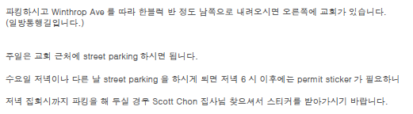

Free street parking is available on weekdays until 6PM on Winthrop ave and Kenmore ave.

For parking after 6PM please contact our staff for parking permit stickers.

We DO NOT have access to Aragorn parking lot this summer festival, please utilize street parking. We apologize for the inconvenience.

